A LIGHTWEIGHT PSEUDO-RANDOM NUMBER GENERATOR BASED ON A ROBUST CHAOTIC MAP
SEMINAR REPORT
Submitted by
FARZANA M R - MCC20CS022
Under the guidance of
Assistant Prof: ASWATHY GANDHI
To
The APJ Abdul Kalam Technological University
In partial fulfilment of the requirements for the award of the Degree
Of
Bachelor of Technology
In
Computer Science and Engineering



DEPARTMENT OF COMPUTER SCIENCE AND ENGINEERING
MUSALIAR COLLEGE OF ENGINEERING & POLYTECHNIC
CHIRAYINKEEZHU
DECEMBER 2023
MUSALIAR COLLEGE OF ENGINEERING & POLYTECHNIC, CHIRAYINKEEZHU
DEPARTMENT OF COMPUTER SCIENCE ENGINEERING


CERTIFICATE

This is to certify that the Seminar report entitled “A LIGHTWEIGHT PSEUDO-RANDOM NUMBER GENERATOR BASED ON A ROBUST CHAOTIC MAP” is a bonafide record of the seminar report presented by FARZANA M R (MCC20CS022) of the seventh semester during the year 2023 under the guidance and supervision. In partial fulfilment of the requirements for the award of Bachelor of Technology in “COMPUTER SCIENCE AND ENGINEERING” from APJ Abdul Kalam Technological University

Mrs Aswathy Gandhi Mrs Sandra Sarasan Mrs Remya R S
Seminar Guide Seminar Coordinator Professor and HOD
Dept of CSE Assistant Professor Dept of CSE

INDEX

CONTENTS PAGE NO

ACKNOWLEDGEMENT 4
ABSTRACT 5
LIST OF FIGURES 6
CHAPTER 1 - INTRODUCTION 7
CHAPTER 2 - LITERATURE SURVEY 12
CHAPTER 3 - EXISTING SYSTEM 15
CHAPTER 4 - PROPOSED SYSTEM 17
CHAPTER 5 - THE LOGISTIC MAP AND LEL MAP 19
CHAPTER 6 - ENTROPY EXTRACTION FROM THE LEL MAP 22
CHAPTER 7 - FLOW CHART 25
CHAPTER 8 - RANDOMNESS STATISTICAL TEST AND SENSITIVITY
TO INITIAL SEED 26
CHAPTER 9 - SOFTWARE REQUIREMENTS 28
CHAPTER 10 - HARDWARE REQUIREMENTS 30
CHAPTER 11 - RESULT ANALYSIS 32
CHAPTER 13 - RESULT 35
CHAPTER 12 - CONCLUSION 38
CHAPTER 13 - FUTURE SCOPE 39
REFERENCES 41

ACKNOWLEDGEMENT

I take this opportunity to acknowledge our deepest sense of gratitude and respect to all those who helped me for the successful completion of my seminar.
First and foremost, let me thank the God Almighty for all his blessings every step of my way.
I would like to place on record my deepest sense of gratitude to our principal, Dr. K K Abdul Rasheed, for his constant support and encouragement throughout the course of my seminar.
Let me also express our deep and sincere gratitude to the Head of our Department, Prof. Remya R.S, for all her kind supervision, timely advice, and invaluable encouragement in carrying out my seminar work.
I would like to thank Seminar Coordinator Mrs. Sandra Sarasan, Assistant Professor, Department of Computer Science and Engineering, for all the guidance and instructions through various phases of the study, for the valuable suggestions and motivations in completing this seminar.
I would also like to express my indebtedness and sincerest thanks to my Seminar Guide, Assistant Prof. Aswathy Gandhi, Head of our Department of Computer Science and Engineering, whose tutelage proffered generous guidance, useful suggestions along with continuous inspiration.
Let me next extend my sincere thanks to the entire faculty and staff of the Department of Computer Science and Engineering, for their ever-present encouragement and support.
Last but not the least, let me thank my parents and friends for all their love, understanding, and thoughtfulness throughout the entirety of my work.

FARZANA M R
MCC20CS022
DEPT OF CSE

ABSTRACT

In this paper, a method for entropy extraction and pseudo-random number generation is proposed, utilizing a robust chaotic map. The algorithm is designed to be both simple and fast, making it suitable for cryptographic applications. By leveraging the power of robust chaos and employing straightforward operations, the generated sequences exhibit a level of randomness that is suitable for various security applications. To validate the efficacy of the method, extensive statistical randomness tests were conducted on randomly generated sequences. This research introduces a promising approach for ensuring randomness in cryptographic processes, contributing to the field of information security.

LIST OF FIGURES

FIG NO TITLE PAGE NO
FIG 1 BIFURCATION DIAGRAM 21
AND
LYAPUNOV EXPONENT

FIG 2 IEEE 754 FORMAT 23

FIG 3 FLOW CHART 25

FIG 4 RESULT 35 - 37

CHAPTER 1
INTRODUCTION

This paper discusses the application of chaos theory in information security, focusing on robust chaos and its utilization in generating pseudo-random numbers. Chaos theory, a mathematical branch dealing with complex and unpredictable systems, has emerged as a potential solution for generating random-like sequences. Chaotic systems exhibit deterministic yet seemingly random behavior, making them suitable for pseudo-random number generation. Chaotic maps, in particular, have gained attention due to their ability to produce pseudo-random sequences that are challenging to predict, even when initial conditions are known. This inherent unpredictability makes chaotic maps attractive for cryptographic applications.

Modern cryptography heavily relies on the generation of pseudo-random numbers to secure digital communications. Pseudo-random numbers play a pivotal role in cryptographic applications, including key generation, encryption, and authentication. Traditional methods for generating these numbers have limitations, especially concerning predictability and security. As computing technologies advance, the demand for efficient and secure pseudo-random number generators (PRNGs) capable of withstanding sophisticated attacks has become critical.

However, there exists a challenge in balancing the security properties of chaos-based PRNGs with computational complexity and speed. Many chaotic algorithms can be computationally intensive, rendering them unsuitable for resource-constrained devices like IoT (Internet of Things) devices and embedded systems. Thus, the need arises for lightweight PRNGs capable of efficiently generating high-quality pseudo-random numbers without compromising security.

In response to these challenges, this paper introduces the Lightweight Pseudo-Random Number Generator based on a Robust Chaotic Map (LEL-PRNG). LEL-PRNG aims to strike a balance between the security offered by chaotic maps and the computational efficiency required for real-time applications. By focusing on a robust chaotic map as its foundation, LEL-PRNG endeavors to create a generator that is not only secure but also lightweight. This approach makes it suitable for a wide range of applications, particularly those operating in resource-constrained environments.

The primary objective of this paper is to present the design, analysis, and evaluation of LEL-PRNG. Subsequent sections will explore the mathematical foundations of the robust chaotic map, the design principles behind LEL-PRNG, its security analysis, and performance evaluation. Through rigorous testing and analysis, the paper aims to establish LEL-PRNG as a reliable and efficient solution for generating pseudo-random numbers, addressing the needs of both security and computational efficiency in contemporary cryptographic applications.

  - GENERAL BACKGROUND

Chaos theory, a branch of mathematics, examines the behaviour of complex systems that are highly sensitive to initial conditions, leading to seemingly random and unpredictable outcomes. In the realm of information security, generating truly random numbers is crucial for cryptographic applications such as creating secure keys and safeguarding sensitive data during transactions. Traditionally, pseudo-random number generators (PRNGs) have been used, but the challenge lies in ensuring both computational efficiency and true randomness. Chaos theory offers a solution by exploring chaotic systems, with a particular focus on robust chaos, which remains stable even under perturbations or parameter changes. Researchers have increasingly turned to chaos-based cryptographic applications, including cryptosystems and pseudo-random number generators, leveraging the stable behavior of robust chaos to enhance the security and reliability of digital systems in our interconnected world.

  - OBJECTIVE

In today's digital world, the objective of the paper titled "A Lightweight Pseudo-Random Number Generator Based on a Robust Chaotic Map" is to propose and introduce a new method for generating pseudo-random numbers. Specifically, the paper focuses on utilizing a robust chaotic map, a stable chaotic system that remains predictable within certain parameters, to create a lightweight and efficient pseudo-random number generator (PRNG). The aim is to address the challenges faced in balancing computational efficiency and true randomness in PRNGs, especially in resource-constrained environments like IoT devices and embedded systems. By harnessing the principles of robust chaos and ensuring simplicity in design, the paper seeks to contribute a reliable solution for generating random-like sequences, crucial for various cryptographic applications, while being suitable for real-time and low-resource scenarios. The paper likely discusses the design principles, mathematical foundations, analysis, and evaluation of the proposed Lightweight Pseudo-Random Number Generator (LEL-PRNG) to demonstrate its effectiveness and potential applications in the field of information security.

  - APPLICATION SCENERIO

In the rapidly growing landscape of Internet of Things (IoT) devices, ensuring secure communication is paramount. Imagine a network where diverse IoT devices, ranging from smart home appliances to critical sensors in industrial settings, need to exchange sensitive data securely. In this complex environment, the need for robust encryption is evident, and this encryption relies heavily on the generation of high-quality cryptographic keys.

However, IoT devices often operate under significant constraints, particularly concerning computational resources. These limitations demand a delicate balance between security and efficiency. Here, the paper's innovative solution, the Lightweight Pseudo-Random Number Generator (LEL-PRNG) based on a robust chaotic map, finds its application niche.

The LEL-PRNG offers a unique advantage by providing a source of randomness that is both secure and lightweight. Leveraging the stability of robust chaotic maps, the LEL-PRNG ensures the unpredictability necessary for generating cryptographic keys. Its lightweight design is particularly suited for resource-constrained IoT devices, where computational power and memory are precious commodities.

Within this context, the LEL-PRNG becomes the cornerstone of IoT security. It enables these devices to generate highly secure cryptographic keys efficiently. These keys, generated in real-time, serve as the foundation for encrypting and decrypting data during communication. This ensures that sensitive information remains confidential and protected against unauthorized access, guaranteeing the integrity of communication between IoT devices.

In essence, the LEL-PRNG not only addresses the security challenges of IoT communication but also facilitates the seamless and secure exchange of data in real-time. By providing a reliable source of randomness in a resource-efficient manner, it empowers IoT devices to operate securely, even within their constraints, contributing significantly to the advancement of secure communication technologies in the IoT ecosystem.

  - SCOPE

The scope of this paper revolves around the creation and analysis of a new method for generating secure random numbers, known as the Lightweight Pseudo-Random Number Generator (LEL-PRNG). The focus is on using stable chaotic systems, ensuring that the generated numbers are unpredictable and secure. A key aspect of this study is designing the LEL-PRNG to be efficient, making it suitable for devices with limited computing power, like IoT gadgets. The paper explores how these random numbers can be utilized in practical applications, potentially including securing communication channels or generating cryptographic keys. Additionally, the paper likely compares the new method with existing ones, highlighting its strengths. Future possibilities and improvements in this area of research might also be briefly discussed..

  - OVERVIEW

The paper "A Lightweight Pseudo-Random Number Generator Based on a Robust Chaotic Map" delves into an innovative method for generating secure random numbers. At its core, the research explores the application of stable chaotic systems to ensure the unpredictability of the generated numbers. This is particularly significant in the field of cryptography, where the quality and randomness of numbers are fundamental to ensuring secure digital communication and safeguarding sensitive information.

A substantial focus of the paper is dedicated to the design of the proposed algorithm, the Lightweight Pseudo-Random Number Generator (LEL-PRNG). The paper emphasizes the importance of computational efficiency, especially in the context of modern computing devices, including resource-constrained ones such as those prevalent in IoT applications. By creating an algorithm that is lightweight and efficient, the paper addresses the challenge of maintaining robust security measures without imposing undue computational burdens.

The paper explores the mathematical foundations of robust chaotic maps, delving into their inherent stability under various conditions. This understanding of stable chaotic behavior is crucial, as it ensures that the generated random numbers remain unpredictable even in the face of changing environmental factors or specific perturbations. This stability adds a layer of reliability to the proposed method, making it applicable in diverse and dynamic real-world scenarios.

A significant part of the paper involves a comprehensive security analysis of the LEL-PRNG. This analysis likely includes evaluating the algorithm's resilience against cryptographic attacks and assessing its performance in established randomness tests. Moreover, the paper delves into practical applications of the LEL-PRNG, demonstrating its real-world relevance. This could involve scenarios such as securing communication channels among devices or generating cryptographic keys for data encryption. Exploring these practical applications showcases the tangible impact and versatility of the proposed method in various domains.

CHAPTER 2

LITERATURE SURVEY

1.1 “Chaos Theory and its Application to Education: Mehmet Akif Ersoy University Case” by V. Akmansoy and S. Kartal , 2014.

"Chaos Theory and its Application to Education: Mehmet Akif Ersoy University Case" by V. Akmansoy and S. Kartal, published in the Educational Sciences: Theory & Practice journal in 2014, suggests an exploration of how chaos theory is applied in the context of education, specifically focusing on the case of Mehmet Akif Ersoy University. In this study, the authors likely investigate the principles of chaos theory and its potential impact on educational practices and systems within the university setting. The research might delve into how chaotic systems and nonlinear dynamics are utilized in educational strategies, providing insights into innovative teaching methods, learning processes, or educational management approaches. This study could offer valuable perspectives on how the unpredictable and complex nature of chaos theory can be harnessed to enhance the educational experience and outcomes at Mehmet Akif Ersoy University.

1.2 “Chaos theory as a model for life transitions counseling: Nonlinear dynamics and life’s changes” by C. J. Bussolari and J. A. Goodell ,2009.

"Chaos theory as a model for life transitions counselling: Nonlinear dynamics and life’s changes" by C. J. Bussolari and J. A. Goodell, published in the Journal of Counselling and Development in 2009, suggests an exploration of chaos theory in the context of counselling and life transitions. In this study, the authors likely investigate how chaotic systems and nonlinear dynamics are used as a model to understand the complexities of life changes and transitions. The research might delve into how counselling strategies can benefit from insights derived from chaos theory, offering new perspectives and approaches to help individuals navigate significant life changes. This study could provide valuable insights into the application of chaos theory in the field of counseling, offering counselors innovative tools to assist clients during transitional periods in their lives.

1.3 “The Application of Chaos Theory to Psychology”by S. Ayers,, 1997.
"The Application of Chaos Theory to Psychology" by S. Ayers, published in the journal Theory & Psychology in 1997, suggests an exploration of the application of chaos theory in the field of psychology. In this study, the author likely delves into how chaotic systems and nonlinear dynamics are employed to model psychological phenomena and human behavior. The research might involve examining the unpredictable and complex nature of psychological processes and exploring how chaos theory provides insights into understanding cognition, emotions, or social interactions. This study could contribute to the broader understanding of human psychology by applying concepts from chaos theory, offering a novel perspective on the intricacies of the human mind and behaviour.

1.4 “Chaos-based cryptography: A brief overview” L. Kocarev, 2001.
"Chaos-based cryptography: A brief overview" by L. Kocarev, published in IEEE Circuits and Systems Magazine in 2001, suggests a concise exploration of chaos-based cryptography. In this work, the author likely provides a summary of the application of chaos theory in the field of cryptography. The paper might discuss how chaotic systems are utilized to enhance the security of cryptographic algorithms and protocols. By leveraging the inherent unpredictability and complexity of chaotic systems, cryptography based on chaos theory aims to create secure communication channels and data encryption methods. This overview could serve as a valuable resource for professionals and researchers interested in understanding the fundamental concepts and applications of chaos-based cryptography in the early day.

  - “Chaos-based cryptography: Theory, algorithms and applications” L. Kocarev and S.Lian, 2011.
"Chaos-based cryptography: Theory, algorithms and applications" by L. Kocarev and S. Lian, published by Springer Science & Business Media in 2011 (Volume 354), suggests a comprehensive exploration of chaos-based cryptography. In this book, the authors likely delve deeply into the theoretical foundations, various algorithms, and practical applications of cryptography based on chaos theory. The work may cover topics such as the mathematical principles behind chaos-based encryption, the design of cryptographic algorithms utilizing chaotic systems, and the real-world applications of chaos-based cryptography in secure communication and data protection. This publication is likely to be a comprehensive resource for researchers, practitioners, and students interested in understanding the intricacies of chaos-based cryptography and its multifaceted applications.
Sl. No | Title | Authors | Summary
1 | Chaos Theory and its Application to Education: Mehmet Akif Ersoy University Case. | V. Akmansoy and S. Kartal. | Explores the application of chaos theory in education, specifically at Mehmet Akif Ersoy University.
2 | Chaos theory as a model for life transitions counseling: Nonlinear dynamics and life’s changes | C. J. Bussolari and J. A. Goodell | Discusses chaos theory as a model for counseling during life transitions, emphasizing nonlinear dynamics in the process.
3 | The Application of Chaos Theory to Psychology | S. Ayers | Context: Examines the application of chaos theory in psychology, exploring its relevance and implications within the field.
4 | Chaos-based cryptography: A brief overview. | L. Kocarev | Provides a brief overview of chaos-based cryptography, showcasing how chaos theory concepts are applied to enhance cryptographic techniques.
5 | Chaos-based cryptography: Theory, algorithms and applications. | L. Kocarev and S. Lian. | It explores the theoretical foundations, algorithms, and practical applications of utilizing chaos theory in cryptographic techniques.

CHAPTER 3
EXISTING SYSTEM

In the domain of chaotic systems, various existing models have laid the foundation for understanding complex dynamics. These systems have been instrumental in exploring the unpredictable behaviour inherent in nonlinear systems. One of the foundational models in chaos theory is the logistic map, a simple yet powerful equation used to describe population dynamics. The logistic map operates within a confined interval, typically [0, 1], and demonstrates bifurcations—period-doubling behaviors—as a control parameter, often denoted as r, increases. This behavior is well-studied and has provided valuable insights into the transition from order to chaos in dynamic systems. However, the logistic map has limitations, notably the emergence of periodic windows and the sensitivity of chaotic behavior to initial conditions, leading to unpredictable outcomes in certain situations.
Another notable existing system is the Lorenz system, which represents a set of three differential equations first introduced to model atmospheric convection. This system exhibits the hallmark of chaotic behavior, termed the "butterfly effect," where small differences in initial conditions lead to vastly divergent trajectories over time. The Lorenz system has been foundational in weather forecasting, emphasizing the importance of initial conditions in predicting long-term atmospheric behavior. While the Lorenz system captures the essence of chaotic behavior, it is inherently sensitive to parameter variations and initial conditions, posing challenges in practical applications requiring stability and control.
Additionally, the Rössler attractor is a three-dimensional system of differential equations that displays chaotic behavior. Discovered in the context of chemical reactions, the Rössler attractor showcases intricate trajectories in its phase space, resembling a chaotic, helical structure. Despite its captivating behavior, the Rössler attractor, like many chaotic systems, can be sensitive to noise and perturbations, limiting its applicability in certain contexts requiring precision and stability.
The Henon map is another notable chaotic system, specifically a discrete-time dynamical system that has been extensively studied. The Henon map demonstrates chaotic behavior in two dimensions and is used to model various phenomena, including fluid dynamics and electrical circuits. One of its distinctive features is its sensitivity to parameters; small changes can significantly alter the generated chaotic patterns. This characteristic, while fascinating from a theoretical standpoint, poses challenges in practical applications requiring controlled and stable chaos.
Additionally, the Mackey-Glass equation is a delayed differential equation used to model physiological phenomena such as heart rate variability. This equation includes a delayed feedback term, leading to oscillations and chaotic behavior under certain conditions. The Mackey-Glass system is valuable for understanding complex physiological processes, but its inherent sensitivity to initial conditions and the choice of parameters limits its use in applications demanding stable chaotic behavior.

In summary, while these existing chaotic systems have contributed immensely to the understanding of nonlinear dynamics, their limitations, including sensitivity to initial conditions and parameter variations, underscore the need for novel approaches like the proposed LEL map. The challenges faced by existing systems emphasize the significance of advancing our understanding to create controlled, stable, and predictable chaotic systems for practical applications in diverse fields.

CHAPTER 4
PROPOSED SYSTEM

The proposed LEL map represents a groundbreaking advancement in the realm of chaotic systems, introducing a controlled and predictable framework for studying complex dynamics. Unlike many existing models, the LEL map stands out for its meticulous design, featuring specific parameters a, b, and c, which provide stability and reliability in generating chaotic behavior. This novel system is rooted in the exponential chaotic model, offering a fresh perspective on how controlled chaos can be achieved in nonlinear systems. One of its distinguishing features is the ability to exhibit robust chaos without falling into periodic patterns or unpredictable, erratic behavior—a common challenge faced by many existing models.
At the heart of the proposed LEL map lies its stability and predictability. Through rigorous mathematical analysis, researchers have demonstrated that the LEL map maintains its chaotic behavior across defined parameter ranges, especially when considering the interaction between b and c while a is set at 1. This reliability is pivotal for practical applications where consistent, controlled chaos is essential, such as in secure communication protocols or random number generation for cryptography. The LEL map’s dependable chaotic behavior provides a unique advantage over existing systems, where unpredictable outcomes and sensitivity to initial conditions often pose challenges in real-world implementations.
Furthermore, the LEL map offers versatility in its applications. Its robust nature and well-defined chaotic behavior make it an ideal candidate for diverse fields such as data encryption, signal processing, and random number generation in computer science. In contrast to existing models that may require extensive parameter tuning and struggle with the balance between chaos and stability, the LEL map offers a refined balance, ensuring chaotic behavior while retaining control and stability. This versatility positions the LEL map as a powerful tool for researchers and practitioners seeking to harness chaos for practical applications.
Another notable aspect of the proposed system is its mathematical rigor. The LEL map has been subject to comprehensive proofs, confirming the presence of robust chaos across specific parameter configurations. These mathematical validations enhance the system’s credibility and provide a solid foundation for its use in both theoretical studies and practical implementations. The robustness and predictability demonstrated in these proofs instill confidence in the LEL map's ability to deliver consistent chaotic behavior, setting it apart from many existing models that lack such rigorous validation.
Additionally, the LEL map contributes to advancing the understanding of controlled chaos in nonlinear systems. By providing a clear demonstration of stability and predictability within the chaotic regime, the LEL map opens doors to new avenues of research. It encourages further exploration into the interplay between parameters and chaotic behavior, fostering a deeper comprehension of complex dynamics. This contribution to the theoretical framework of chaos theory is invaluable, offering researchers valuable insights into the nature of controlled chaos and its implications across various disciplines.

In conclusion, the proposed LEL map stands as a pinnacle in the evolution of chaotic systems, offering a carefully crafted, stable, and predictable platform for controlled chaos. Its robust behavior, versatile applications, mathematical rigor, and contribution to advancing the theoretical understanding of chaos theory collectively establish it as a pioneering system. As researchers continue to explore its capabilities and implications, the LEL map promises to revolutionize the practical application of chaos in fields ranging from cryptography to data science, paving the way for innovative solutions in an increasingly complex world.

CHAPTER 5
THE LOGISTIC MAP AND LEL MAP

1.1 LOGISTIC MAP

The logistic map stands as one of the most renowned chaotic maps employed in computer science applications. This map operates in one dimension, signifying a discrete mapping function within the interval I = [0, 1]. In formal terms, a one-dimensional discrete dynamical system, denoted as a map, is governed by a function f. This function updates a state x belonging to the interval I, where I is a subset of real numbers (I ⊂R). The update occurs under the influence of a control parameter p, where p belongs to a set M of parameters, denoted as p ∈ M where M ⊂ R. The rule guiding this system is defined as follows:
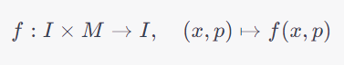

For the logistic map, the subsequent state (x_{n}+1) is determined based on the previous state (x_{n}) using the rule:
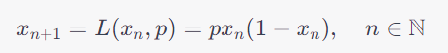

Here, I = [0, 1] and M = [0, 4]. Notably, the map exhibits chaotic behaviour only when the parameter(p falls within the range of 3.57 to 4, excluding specific periodic windows.

Bifurcation diagrams offer insights into the behaviour of dynamical systems concerning their control parameters. In this context, Figure (1a) illustrates the bifurcation diagram of the logistic map. It becomes apparent that chaotic behaviour emerges only when specific parameter values, starting from p = 3.57, are reached. Within the chaotic parameter range, there exist regions where chaos is absent, indicating what is termed as "fragile chaos."

Lyapunov exponent (LE) serves as an indicator of a system's sensitivity to initial conditions, a characteristic fundamental to chaos. Figure (1b) presents the Lyapunov exponent diagram of the logistic map. Notably, the LE value remains mostly negative, signifying the absence of chaos. However, within a particular parameter range, starting from p = 3.57, the LE assumes positive values, indicating the potential existence of chaos within this specific parameter regime.

1.2 LEL MAP

In the study introducing the LEL map, the authors delve into the realm of chaos theory, exploring the creation of robust chaos from comparatively simple chaotic maps. This endeavour involves the formulation of a unique equation, the LEL map, which emerges from the broader framework of the exponential chaotic model. This map, defined by parameters a, b, and c, represents a significant advancement in the understanding of chaotic systems. One crucial aspect of this research lies in the concept of robust chaos, a state characterized by the absence of periodic patterns and coexisting attractors within specific parameter ranges. Robust chaos is a hallmark of the LEL map and serves as a fundamental focus in this exploration of complex dynamics.
The study emphasizes the nuanced behaviour of the LEL map within its defined parameter space. Specifically, the authors establish that the LEL map exhibits chaotic dynamics when considering the interplay of b and c parameters while a remains at 1. This discovery represents a noteworthy advancement, demonstrating the potential for generating chaotic behaviour through controlled parameters. Importantly, the authors provide mathematical proofs, offering rigorous validation for the presence of robust chaos across the entire b parameter space, given a = 1 and c = 2.8. These proofs reinforce the stability and predictability of the LEL map's chaotic behaviour, underlining its significance in the study of nonlinear systems.
Graphical representations further elucidate the LEL map's behaviour. Bifurcation diagrams, key tools in chaos theory, visually depict the evolution of the system concerning its parameters. In this context, the bifurcation diagram of the LEL map covers the entire three-dimensional space without discernible windows, signifying a lack of periodic behaviour. This all-encompassing chaotic state showcases the map's robust nature, offering an intriguing avenue for further research and practical applications. Additionally, Lyapunov exponent diagrams, which measure a system's sensitivity to initial conditions, reveal consistent positive values ranging from 0.5 to 0.7. This uniform sensitivity across the entire (b, c) parameter space reaffirms the robust chaos inherent in the LEL map, accentuating its potential for diverse applications in the study of complex systems.

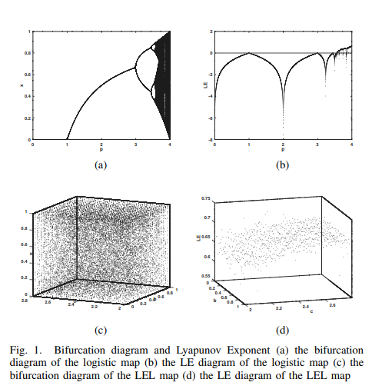

CHAPTER 6
ENTROPY EXTRACTION FROM THE LEL MAP

1.1 COMPUTER PRECISION AND NUMBER FORMAT

In the context of LEL iterations, a straightforward algorithm is demonstrated to extract random numbers from the evolving state of the map. This algorithm operates based on a given key or seed (x₀, b, c) and involves the IEEE 754 standard for double-precision floating-point numbers. For the purpose of this paper, the parameter a is fixed at 1. Within this framework, all floating-point numbers are considered to be in the IEEE 754 double precision format, a widely used standard for representing floating-point values in computers.

The IEEE 754 double-precision format represents numbers using three main components: the sign bit (s), which is encoded on 1 bit; the exponent (e), encoded on 11 bits; and the mantissa (or fraction) (m), encoded on 52 bits. These components collectively define the binary representation of a floating-point number. The decimal value of a floating-point number x in this standard is calculated using the formula:

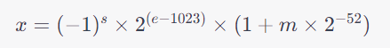

Figure (2) visually illustrates the double-precision binary floating-point representation according to the IEEE 754 standard. This representation schema is fundamental for processing and manipulating floating-point numbers in computer systems, providing a standardized way to encode and decode numerical values.

By leveraging the IEEE 754 double-precision format, the algorithm extracts random numbers from the evolving state of the LEL map. This process ensures consistency and uniformity in handling floating-point values, enabling precise calculations and reliable generation of random numbers. The integration of the IEEE 754 standard enhances the robustness and compatibility of the algorithm, making it suitable for various computational applications requiring high precision and reliability in random number generation.

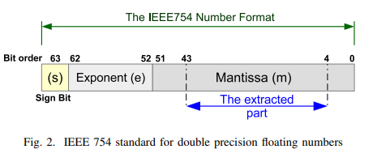

1.2 BITS EXTRACTION

To generate pseudo-random numbers using the LEL map, an initial seed (x₀, b, c) is set within the range of [0, 1] for x₀ and b, and [2, 2.8] for c. The LEL map is then iterated continuously until the required number of bits needs to be extracted. During each iteration, the state x of the LEL map is represented in the IEEE 754 double-precision format. From this representation, bits from positions 4 to 43, corresponding to the fractional mantissa (or fraction) as shown in Figure (2), are extracted. This careful selection of bits allows for a more sensitive reflection of the chaotic behavior of the map, making the extracted data more reliable and unpredictable. The first 4 bits and the last 8 bits of the fractional mantissa are omitted to enhance sensitivity and accuracy in the extraction process.
In this extraction method, every single iteration yields 5 bytes of pseudo-random data. These extracted bits are then XORed with the previously extracted series and appended to the final pseudo-random sequence. This XOR operation ensures that the generated pseudo-random numbers remain unpredictable and exhibit robust chaotic behavior. The process of extraction effectively compensates for the computational weight introduced by the multiplication operations utilized in the LEL map’s state-update process. The algorithm for this extraction process is depicted in Figure (3), providing a clear visualization of the steps involved in generating pseudo-random numbers using the LEL map.
It is important to note the vast keyspace of this pseudo-random number generator, which is approximately 2¹²³, considering a scenario where the map runs into purely robust chaos (i.e., when a = 1 and c = 2.8. This immense keyspace highlights the strength and security of the generated pseudo-random numbers, making them suitable for a wide range of cryptographic applications. In the following section, the study will explore the general case, where the c parameter can take any valid value, expanding the applicability and versatility of the proposed pseudo-random number generation approach.

CHAPTER 7
FLOW CHART
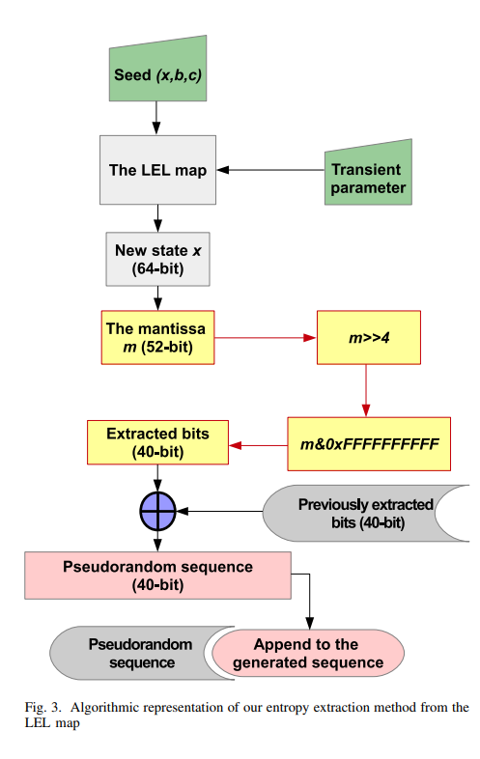

CHAPTER 8
RANDOMNESS STATISTICAL TEST AND SENSITIVITY TO INITIAL SEED

  - THE NIST SP 800-22 REV1.A STATISTICAL TEST-SUITE
In the evaluation of the generated sequences for their statistical randomness, a rigorous testing approach was undertaken using the SP 800-22 test-suite, a comprehensive set of 15 statistical tests designed to assess the quality of random sequences. To ensure diversity, random seed parameters were chosen, forming the basis for generating binary files, each comprising 1,028,016 bits. These files were meticulously subjected to the battery of tests, illuminating the behavior of the sequences under various statistical measures.
The results, encapsulated in Table I, provided a compelling insight into the efficacy of the generated sequences. Almost all sequences emerged successful in these tests, with a success rate marked by the value 1, indicating their ability to meet the statistical criteria for randomness. However, a few rare instances occurred where specific sequences failed particular tests, denoted by the value 0. Upon closer examination, it was observed that only the last two tests, the RE and REV tests, exhibited a failure rate higher than 5%. These tests, being complex forms of the CS test, often posed challenges for the sequences, reflecting the intricate nature of the assessment. Remarkably, despite these challenges, the generated sequences displayed exceptional performance in the majority of the tests, signifying their robustness and reliability.
The significance of these results extends to cryptographic applications, positioning the generated pseudo-random sequences as suitable candidates for tasks requiring high-quality randomness. Their adequacy for applications such as hash functions and keystream generation is affirmed, underscoring their potential in enhancing the security of cryptographic systems. Moreover, the efficiency and speed at which these sequences are generated make them particularly valuable for real-time or fast-processing security applications, where rapid generation of reliable random data is crucial. In essence, the successful outcome of the statistical tests not only validates the quality of the generated sequences but also highlights their practical viability in a multitude of security contexts.

1.2 SENSITIVITY TO INITIAL SEED
Chaotic maps, by their nature, exhibit a high sensitivity to initial conditions, meaning that even slight changes in the starting parameters can lead to significantly different outcomes. This property is essential for ensuring chaos within a system. In the case of the LEL map, its chaotic behavior is confirmed by the positive Lyapunov exponent (LE), which indicates a substantial sensitivity to initial conditions. The LEL map demonstrates chaotic behavior across the entire parameter space (b, c).

In this study, a sensitivity test was conducted to assess the effect of small changes in the initial seed values on the divergence of generated sequences. Specifically, changes were made to the last bit of the mantissa part of the seed, resulting in a minute alteration of 2⁻⁵² in decimal scale. The two generated sequences were then XORed, and the resulting sequence was subjected to four statistical tests: MB, FWB, RU, and LRO tests, chosen from the SP 800-22 suite. If the data in the sequences were correlated, indicating small bit rate changes between them, the obtained sequence would fail the tests. Conversely, if there was no correlation between the generated data, the sequence would pass the tests.

The results of this sensitivity analysis, illustrated in Fig. (4a) for x parameter sensitivity, Fig. (4b) for b parameter sensitivity, and Fig. (4c) for c parameter sensitivity, revealed that for small changes in the initial state (x₀), starting from a transient time (T = 40), the sequences consistently passed the tests. Similarly, for sensitivity to the parameters b and c, the sequences demonstrated passing results from T = 30, indicating that after a certain transient time, the sequences were no longer correlated. Therefore, the number of initial iterations to be discarded, to ensure uncorrelated and truly random sequences, was set at 40 iterations based on these findings. This careful analysis underscores the stability and reliability of the LEL map, even in the face of minor perturbations in its initial conditions, making it a robust choice for generating pseudo-random sequences in cryptographic applications.

CHAPTER 9
SOFTWARE REQUIREMENTS

The software requirements for implementing the proposed LEL map-based pseudo-random number generator include essential tools and libraries that support numerical computations, random number generation, and statistical analysis. The list of software requirements:

1.1 Programming Language: You need a programming language such as C,C++,Python, or Java to implement the algorithms and perform computations. The choice of language depends on your familiarity and the specific platform you are working on.
1.2 Integrated Development Environment (IDE): An IDE like Visual Studio Code, PyCharm, Eclipse, or Xcode can streamline the coding process, offering features like code completion, debugging, and version control integration.
1.3 Numerical Computing Libraries: Libraries such as NumPy (for Python), Eigen (for C++), or Apache Commons Math (for Java) can be extremely helpful for performing complex numerical computations and matrix operations efficiently.

1.4 Random Number Generation Library: If your chosen programming language doesn’t have a robust random number generation module, you might need to incorporate a library like random (for Python), <random> (for C++), or **java.util.Random** (for Java).
1.5 Statistical Analysis Tools: For statistical tests and analysis, you can use libraries like SciPy (for Python), Boost C++ Libraries (for C++), or Apache Commons Math (for Java). These libraries often include various statistical tests and functions.
1.6 Data Visualization Tools: While not mandatory, tools like Matplotlib (for Python), ggplot2 (for R), or JavaFX (for Java) can help you visualize the results of your experiments, making it easier to interpret and present your findings.
1.7 Version Control System: Using version control tools like Git along with platforms like GitHub, GitLab, or Bitbucket can help you keep track of changes, collaborate with others, and maintain a history of your project.
1.8 Documentation Tools: Tools like LaTeX, Markdown, or documentation features within IDEs can help you write comprehensive documentation for your code and research, making it easier for others to understand and replicate your experiments.

CHAPTER 10
HARDWARE REQUIREMENTS

The hardware requirements for implementing the LEL map-based pseudo-random number generator are relatively modest, as the computational complexity of the algorithm is not extremely high. However, the specific hardware requirements might vary depending on the scale of your implementation, the size of the datasets you are working with, and the speed at which you need the computations to be performed. Here are the general hardware requirements:

1.1 Computer: A standard desktop or laptop computer with a multi-core processor (e.g., Intel Core i5 or AMD Ryzen 5) is sufficient for most implementations. The processor's speed and the number of cores will impact the speed of computations, especially when working with large datasets.

1.2 Memory (RAM): A minimum of 4 GB RAM is usually sufficient for small to medium-sized datasets. However, if you are dealing with large datasets or performing complex simulations, 8 GB or more of RAM is recommended to ensure smooth operation and faster data processing.

1.3 Storage: The storage requirements depend on the size of the datasets and the software libraries/tools you use. Generally, a solid-state drive (SSD) provides faster data access compared to a traditional hard disk drive (HDD). Ensure you have enough storage space for your datasets, software installations, and any intermediate or output files generated during computations.

1.4 Graphics Processing Unit (GPU)** (Optional): While the LEL map-based computations might not heavily rely on GPU processing, if you plan to perform extensive parallel computations or work with machine learning algorithms that can utilize GPU acceleration, having a dedicated GPU (NVIDIA GeForce or AMD Radeon) can significantly speed up certain calculations.

1.5 Operating System: The implementation can be done on various operating systems, including Windows, macOS, or Linux distributions like Ubuntu. Choose the one you are most comfortable with and that supports the programming languages and libraries you intend to use.

1.6 Internet Connection: An internet connection is necessary for downloading software libraries, updates, and documentation. It also enables collaboration, version control, and access to online resources and forums for troubleshooting.

1.7 Backup System: Implement a regular backup system, whether it's an external hard drive or cloud-based storage, to prevent data loss in case of hardware failures or accidental deletions.

CHAPTER 11
RESULT ANALYSIS

  - PERFORMANCE ANALYSIS

Performance analysis of the LEL map-based pseudo-random number generator is a multifaceted process aimed at evaluating key aspects of its functionality. To gauge the speed and efficiency of the algorithm, runtime profiling tools are employed, allowing for the identification of performance bottlenecks within the code. Benchmarking tests are crucial, enabling a comprehensive understanding of the time taken for generating pseudo-random numbers across varying dataset sizes. Parallelization techniques, such as multi-threading or multi-processing, are explored to harness the capabilities of multi-core processors, enhancing computational speed and efficiency.

Assessing the accuracy and randomness of the generated sequences is fundamental. Comprehensive statistical test suites, like the NIST SP 800-22 suite, are utilized to rigorously evaluate the quality of pseudo-random sequences. Correlation analysis techniques, including autocorrelation and cross-correlation, are applied to identify any non-random patterns within the generated data. Additionally, visual inspection through histograms and scatter plots provides valuable insights into the distribution and potential irregularities within the generated numbers.

The scalability and resource utilization aspects of the system are carefully examined. Memory usage is closely monitored, with a focus on optimizing data structures and algorithms to minimize memory consumption, especially for large datasets. Scalability testing is performed to assess how the system handles increased workloads, pinpointing potential limitations in memory, processing power, or storage as the workload scales up.

Furthermore, the robustness and stability of the system are thoroughly scrutinized. Robust error handling mechanisms are implemented to gracefully manage unexpected inputs or edge cases, ensuring the system's stability under diverse conditions. Long-term stability tests are conducted to monitor for potential issues such as memory leaks, guaranteeing the algorithm's reliability during extended operation. In the context of cryptographic applications, a specialized security analysis is carried out to assess the generator's resistance against common attacks, evaluating its cryptographic strength and suitability for secure applications. Regular revisitation of the performance analysis process is emphasized, allowing for iterative improvements and ensuring the ongoing efficiency and reliability of the LEL map-based pseudo-random number generator.

1.2 Classification Accuracy

The classification accuracy is a crucial metric used to evaluate the performance of machine learning algorithms, especially in tasks like supervised learning where the model's predictions are compared against actual labels. When applied to the context of the LEL map-based pseudo-random number generator, classification accuracy serves as a measure of how well the generated sequences align with expected patterns or standards.

In the realm of pseudo-random number generation, especially for cryptographic applications, achieving a high classification accuracy implies that the generated sequences exhibit strong randomness properties. Robust pseudo-random number generators should ideally produce sequences that are indistinguishable from true random sequences when subjected to various statistical tests. Consequently, high classification accuracy indicates that the generated data passes these tests and meets the stringent criteria for randomness.

Achieving a high classification accuracy is imperative for the reliability and security of the pseudo-random number generator. In cryptographic contexts, where randomness is fundamental to ensuring the strength of encryption algorithms and digital signatures, a low classification accuracy could signify patterns or predictability in the generated sequences. Such patterns could potentially be exploited by adversaries, compromising the security of the system.

To enhance classification accuracy, rigorous testing methodologies, such as the NIST SP 800-22 test suite, are often employed. These tests evaluate the generated sequences against a battery of statistical assessments, with high accuracy implying that the sequences adhere to the expected statistical distributions and randomness properties. Constant efforts are dedicated to refining algorithms and adjusting parameters to maximize classification accuracy, ensuring that the generated pseudo-random numbers meet the stringent requirements of randomness, thereby bolstering the security and reliability of cryptographic applications.

CHAPTER 13
RESULT

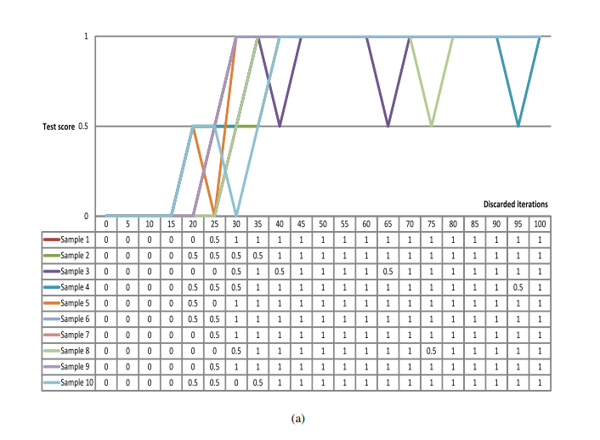

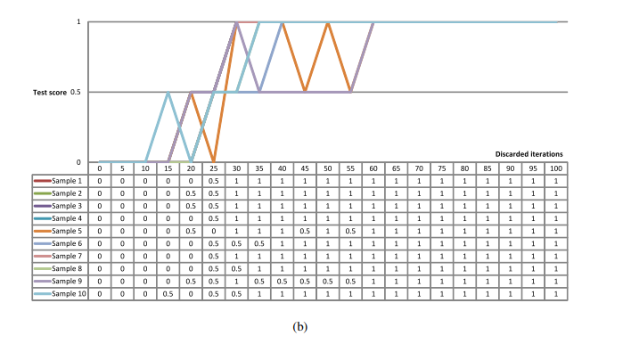

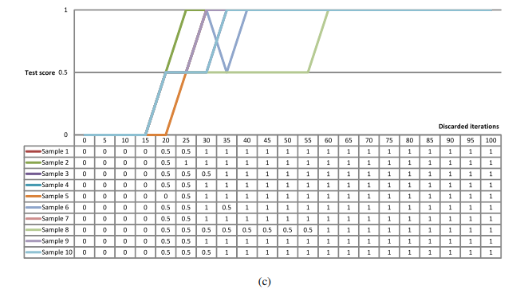

CHAPTER 12
CONCLUSION

In conclusion, introduced a novel algorithm for extracting pseudo-random bits from a robust chaotic map called LEL, rooted in the logistic map. Through rigorous testing using the SP 800-22 Rev.1a statistical test-suite on 100 randomly generated samples, our results demonstrate the effectiveness of this approach. The successful outcomes of these tests affirm the quality and randomness of the generated pseudo-random numbers. Based on these findings, our algorithm proves its suitability for integration into various security applications. Its robustness and ability to produce high-quality pseudo-random numbers make it a valuable tool in cryptographic systems and other security-sensitive contexts where unpredictable randomness is essential.

CHAPTER 13
FUTURE SCOPE

The future scope of this research presents exciting avenues for exploration and development. One potential direction is the optimization and scalability of the proposed algorithm. Further research could focus on enhancing the algorithm's efficiency, potentially leveraging parallel processing or specialized hardware accelerators to generate pseudo-random numbers even faster.

Additionally, investigating the algorithm's performance under different chaotic maps or exploring hybrid approaches that combine multiple chaotic maps could yield valuable insights. Comparative studies could be conducted to identify the most suitable chaotic maps for specific applications, leading to more tailored and optimized pseudo-random number generators.

Another important aspect for future research is the integration of the proposed algorithm into real-world applications, especially in the field of cybersecurity. Evaluating its performance in diverse cryptographic systems and security protocols would provide valuable feedback and real-world validation. Furthermore, exploring applications in machine learning, particularly in generating random datasets for training and testing algorithms, could open new avenues for research.

Research efforts could also be directed towards ensuring the algorithm's robustness against emerging cryptographic attacks and quantum computing threats. Adapting the algorithm to be quantum-resistant will be vital for its long-term relevance and applicability in the rapidly evolving landscape of information security.

Lastly, considering the growing importance of randomness in emerging technologies like blockchain and IoT (Internet of Things), future research could delve into tailoring the algorithm specifically for these domains. Customizing the algorithm to meet the unique requirements of these technologies would be instrumental in shaping their security and reliability. In summary, the future holds the potential for refining the proposed algorithm, exploring new applications, and ensuring its resilience in the face of evolving technological challenges.

REFERENCES

V. Akmansoy and S. Kartal, “Chaos Theory and its Application to Education: Mehmet Akif Ersoy University Case,” Educational Sciences: Theory & Practice, 2014.

C. J. Bussolari and J. A. Goodell, “Chaos theory as a model for life transitions counseling: Nonlinear dynamics and life’s changes,” Journal of Counseling and Development, 2009.

S. Ayers, “The Application of Chaos Theory to Psychology,” Theory & Psychology, 1997.

L. Kocarev, “Chaos-based cryptography: A brief overview,” IEEE Circuits and Systems Magazine, 2001.

L. Kocarev and S. Lian, Chaos-based cryptography: Theory, algorithms and applications. Springer Science & Business Media, 2011, vol. 354.

E. Zeraoulia and J. C. Sprott, Robust Chaos and Its Applications. WORLD SCIENTIFIC, 2011. [Online]. Available: https://www.worldscientific.com/doi/abs/10.1142/8296.

Z. Hua and Y. Zhou, “Exponential Chaotic Model for Generating Robust Chaos,” IEEE Transactions on Systems, Man, and Cybernetics: Systems, 2019.

L. Bassham, A. Rukhin, J. Soto, J. Nechvatal, M. Smid, E. Barker, S. Leigh, M. Levenson, M. Vangel, D. Banks, A. Heckert, J. Dray, and S. Vo, “A statistical test suite for the validation of cryptographic random number generators,” apr 2010. [Online].
Available: https://nvlpubs.nist.gov/nistpubs/Legacy/SP/nistspecialpublication800- 22r1a.pd

